SIT718 Real world Analytics

End Term Assessment Report

Name: Mandar Mukund Khire

Student ID:



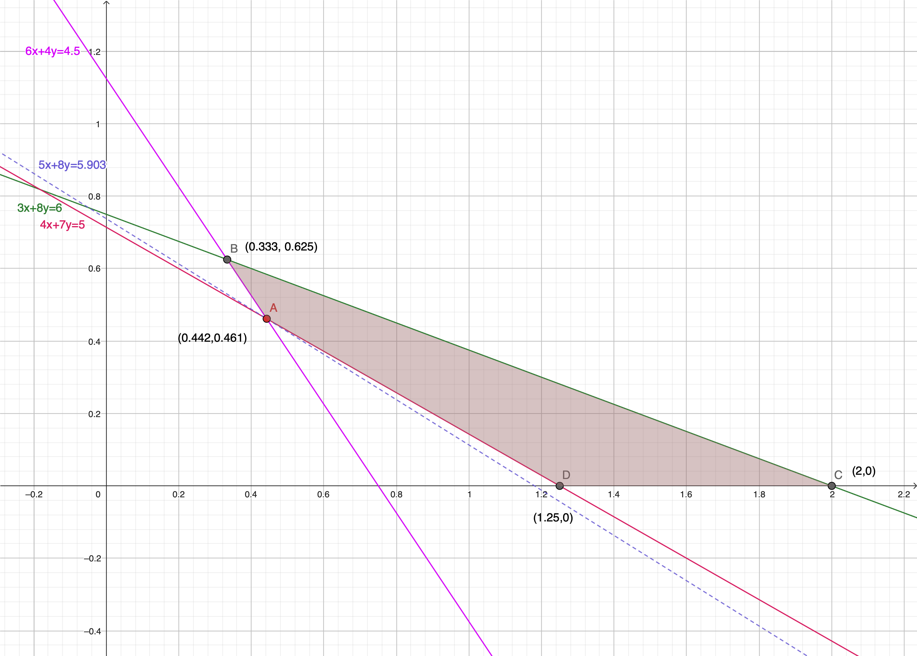

Question 1: Cheese Factory – LP Graphical Resolution

Solution 1(a) – Why Linear Programming Model?

Few Observations regarding the data provided:

* The cost function provided is linear in nature. For example, cost for 1kg of cheese preparation for product A and B is $5 and $8 respectively. This can be represented easily via a linear equation.
* The variable for quantification for milk and the product cheese do have a linear relationship. For example, for product A, to prepare 1000 kg of milk 30 litre of sheep milk is required. This can be represented in the linear equation. This helps us express the constraints in the form of linear equation.

**Since the different variables and the constraints and objective all follow linear relationship, Linear Programming model is suitable for this problem.**

Solution 1(b) – Linear Programming Model Formulation

Objective Function

Constraint C1

Constraint C2

Constraint C4

* Variables Assumptions and Objective:
* Objective is to minimize the cost of cheese production within the provided constraints.
* Overall cost = Production Cost for Product A + Production Cost for Product B
* Let’s assume that X kg of cheese is prepared using Product A and Y kg is prepared using Product B.
* From the provided data, the Objective Function is formulated as below

Overall Cost *Min Z = 5X + 8Y*

* Constraints
* Each Product type has a specific composition of milk types and there are some constraints on the overall summation of milk types. This helps us derive three more constraints as below:

Sheep Milk 🡪 30X + 80)Y <= 60

🡪 3X + 8Y <= 6

* Similarly for Cow and Goat, below constraints are derived:
* Cow milk 🡪 6X + 4Y >= 4.5
* Goat milk 🡪 4X + 7Y >= 5
* Non Zero limit 🡪 In addition to above four constraints, there is an assumption that all variables are non-zero.

Solution 1(c) – Graphical Solution

* Approach
* Plot the linear equations of all the constraints (C1 to C3 as mentioned above). (Substitute all the “less than” or “greater than” operators to “equal to”).
* As all the variables are assumed to be non zero, the solutions lies in Quadrant 1.
* Every constraint line separates the Q1 – one part towards Origin and other away from the Origin.
* The graphical solution is implemented in the graph below. (Small hand drawn arrows shows the area of the Q1 to be considered for feasible region.
* Optimal Solution
* We need to minimize the cost and hence the Optimum solution would require the Objective Value to be minimum.
* We have four corner points (A, B, C and D) for the feasible region and let’s calculate the Objective value for each point. Below chart will provide the right picture for us.

|  |  |  |  |
| --- | --- | --- | --- |
|  | X-Coordinate | Y-Coordinate | Objective Value |
| Point A | **0.442** | **0.461** | **5.903** |
| Point B | 0.333 | 0.625 | 6.666 |
| Point C | 0.125 | 0 | 6.250 |
| Point D | 0.2000 | 0 | 10.000 |

* Looking at above calculations, as Point A (0.442, 0.461), we have minimum Objective Value (5.903).
* So Optimal solution is (rounded to nearest Decimal)
  + **Overall cost: $5.903/kg**
  + **Product A Cheese Production: 0.442 kg**
  + **Product B Cheese Production: 0.461 kg**
* Feasible region
* The feasible region lies towards the Origin for line C2 and away from the Origin for lines C1, C3 and C4 in Q1. Below table is helpful for the same:

|  |  |  |  |  |
| --- | --- | --- | --- | --- |
| Constraint | Equation | Value post Origin substitution | Solution towards Origin | Solution Away from the Origin |
| C1 | 3x + 8Y <= 6 | 0 <= 6 (True) | True | False |
| C2 | 6x + 4Y >= 4.5 | 0 >= 4.5 (Not True) | False | True |
| C3 | 4x + 7Y >= 5 | 0 >= 5 (Not True) | False | True |

* Feasible region is drawn based on the guidelines provided in above table and the quadrilateral ABCD is turned out to be the feasible region. (Shaded in the graph above).
* Range for the cost of A
* The equation of the line for Objective function with the value as Optimum value is 🡪 5X + 8Y = 5.903
* The line is drawn with this equation and is displayed in the graph above shown in dotted format.
* The line doesn’t pass through the feasible region except for the optimal point (point A) which is identified as the

optimal solution as above.

* This means that there is no other value of X and Y, which satisfies the Objective Function with Optimal value

and passes through the feasible region.

* From this observation, it is concluded that the only value of Product A as 0.442 is the optimum point with

lowest cost of $5.903/kg

Solution 1(d) – Range for the cost of A keeping Optimum Point

Solution 2(a): Design of LP Model

Question 2: LP Model for Food Factory

* Objective:

The objective is to maximize profit and for that determine the optimal production mix of cereals and the associated amounts of ingredients using Linear Programming.

Let xij be the decision variable that denotes the number of kg of ingredient i, where i could be Oates, Apricots, Coconuts, Hazelnuts, used to produce Cereal j, here j is one of A,B,C, (in boxes)

|  |  |  |  |  |
| --- | --- | --- | --- | --- |
|  | Oates | Apricots | Coconuts | Hazelnuts |
| Cereal A | X11 | X21 | X31 | X41 |
| Cereal B | X12 | X22 | X32 | X42 |
| Cereal C | X13 | X23 | X33 | X43 |

* Total Sales

We have Sale price per box for each cereal type. With our above assumptions, we can derive the equation for overall weight (in kg) per cereal type which will help us provide the equation for total sales price.

*Total Sales = (X11 + X21 + X31 + X41) * (2.50) + (X12 + X22 + X32 + X42) * (2.00) + (X13 + X23 + X33 + X43) * (3.50)*

* Total Prod Cost

We have Production cost for each cereal type per ton. Our assumption variables are in terms of kg. So we can identify the equation for total Prod cost as below by converting the rate for per kg. The equation would look like below:

*Total Prod Cost = = (X11 + X21 + X31 + X41) * (4/1000) + (X12 + X22 + X32 + X42) * (2.8/1000) + (X13 + X23 + X33 + X43) * (3.00/1000)*

* Total Purchase Cost

We can arrive at the equation for total purchase cost by adding our assumption variables and multiplying it with the purchase rate provided as below:

*Total Purchase Cost = (X11 + X12 + X13) * (100/1000) + (X21 + X22 + X23) * (120/1000) + (X31 + X32 + X33) * (80/1000) + (X41 + X42 + X43) * (200/1000)*

* Objective Function

Total Profit = Total Sales Cost – Total Production Cost – Total Purchase cost

By equating, above equations and simplifying, we arrive at below Objective function:

*Max Z = 2.396X11 + 2.376X21 + 2.416X31 + 2.296X41 + 1.892X12 + 1.8772X22 + 1.9172X32 + 1.7972X42 + 3.397X13 + 3.377X23 + 3.417X33 + 3.297X43*

* Constraints:

Minimum Demand

Maximum Availability

*Oats 🡪 X11 + X12 + X13 <= 10000*

*Apricots 🡪 X21 + X22 + X23 <= 5000*

*Coconuts 🡪 X31 + X32 + X33 <= 2000*

*Hazelnuts 🡪 X41 + X42 + X43 <= 2000*

*Cereal A 🡪 X11 + X21 + X31 + X41 >= 1000*

*Cereal B 🡪 X12 + X22 + X32 + X42 >= 700*

*Cereal C 🡪 X13 + X23 + X33 + X43 >= 750*

Proportions of different Ingredients

Different Ingredients in different cereals are present with different proportions with each other. This proportion constraints are captured in terms are mathematical equations as below:

Cereal B

Cereal A

*X13 – 5X23 = 0*

*X13 – 5X33 = 0*

*X13 – 1.67X43 = 0*

Cereal C

*X12 – 3.25X22 = 0*

*X12 – 13X32 = 0*

*X12 – 6.5X42 = 0*

*X11 – 8X21 = 0*

*X11 – 16X31 = 0*

*X11 – 16X41 = 0*

* Summary of the LP Model

|  |  |
| --- | --- |
| Linear Programming Model for Food Factory | |
| Objective | **Maximize Profit** |
| Total Number of Variables | **12** |
| Total Number of Constraints | **16** |
| Bounds for the variables | **All variables non zero integers** |

Solution 2(b): LP Model Implementation using R

Key Details of R Implementation:

* Use of lpSolveAPI package for LP solution
* The Objective function variables and constraints are documented in the tabular format before invoking lpSolveAPI functions. (Please refer below table.
* The Optimal Profit Value and Optimal values of decision variables are derived and documented in the next section.

Table with Variables and values for lpSolveAPI Implementations



Optimal Profit and Optimal Values of Variables

Optimal Profit : $38729.35

|  |  |  |  |  |
| --- | --- | --- | --- | --- |
|  | Oates | Apricots | Coconuts | Hazelnuts |
| Cereal A | X11 = 6880 | X21 = 860 | X31 = 430 | X41 = 430 |
| Cereal B | X12 = 455 | X22 = 140 | X32 = 35 | X42 = 70 |
| Cereal C | X13 = 2505 | X23 = 501 | X33 = 501 | X43 = 1500 |